EC-231 Operating Systems
BS(CE)-2021
LAB REPORT # 11

Submitted By:
Reg. No. | Name
21-CE-009 | Huzaifa Shahbaz
21-CE-020 | Muhammad Ibthesam
21-CE-021 | Yawar Ali Malik
Department of Computer Engineering
BS Computer Engineering Program
HITEC University Taxila
 | Presentation  (Format (0.5) + Title (0.5) +  Conclusion(1) + Procedure(2) + Objective(1)) | Calculation/Coding | Observation/ Program Results | Total
Total | 5 | 5 | 5 | 15
Obtained

___________________________ Lab Instructor. Engr. Fasih Ahmad
Experiment #11
Implementation of Priority Scheduling Algorithm
Objective: In this lab we will learn the implementation of Priority Scheduling Algorithm.

Software Used: 1Virtual box 2.Ubuntu 3.Sublime text editor 4.GCC COMPLIER

Procedure: Priority scheduling is one of the most common scheduling algorithms in batch systems. Each process is assigned a priority. Process with the highest priority is to be executed first and so on. Processes with the same priority are executed on first come first served basis. Priority can be decided based on memory requirements, time requirements or any other resource requirement. Characteristics of Priority Scheduling: • A CPU algorithm that schedules processes based on priority. • It used in Operating systems for performing batch processes. • If two jobs having the same priority are READY, it works on a FIRST COME, FIRST SERVED basis. • In priority scheduling, a number is assigned to each process that indicates its priority level. • Lower the number, higher is the priority. • In this type of scheduling algorithm, if a newer process arrives, that is having a higher priority than the currently running process, then the currently running process is preempted. Difference between Primitive and non-primitive: Primitive: 1. In Preemptive Scheduling, the CPU is allocated to the processes for a specific time period. 2. In Preemptive Scheduling, tasks are switched based on priority Non-Primitive: 1. In non-preemptive scheduling CPU is allocated to the process until it terminates. 2. In non-Preemptive Scheduling, tasks, no switching takes place. Algorithm: 1. Input the processes along with their burst time (bt). 2. Get the priority for each process and value. 3. Start with the higher priority process from its initial position let other processes to be in queue i.e. sort processes according to their priorities. 4. If more than 1 process has same burst time, then FCFS algorithm will be followed. 5. Find waiting time (wt) for all processes. 6. As first process that comes need not to wait so waiting time for process 1 will be 0 i.e. wt[0] =0. 7. Find waiting time for all other processes i.e., for process i,wt[i] = bt[i-1] + wt[i-1]. 8. Find turnaround time = waiting_time + burst_time for all processes. 9. Find average waiting time = total_waiting_time / no_of_processes. 10. Similarly, find average turnaround time = total_turn_around_time / no_of_processes. 11. Compute Average Waiting Time of processes. 12. Compute Average Turnaround Time of processes. 13. Display the Gantt chart.

Tasks
Task 1: Implement priority scheduling algorithm for preemptive processes. 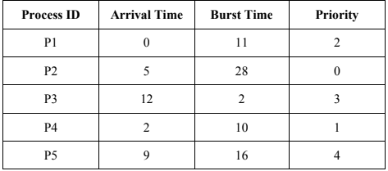 CODE: 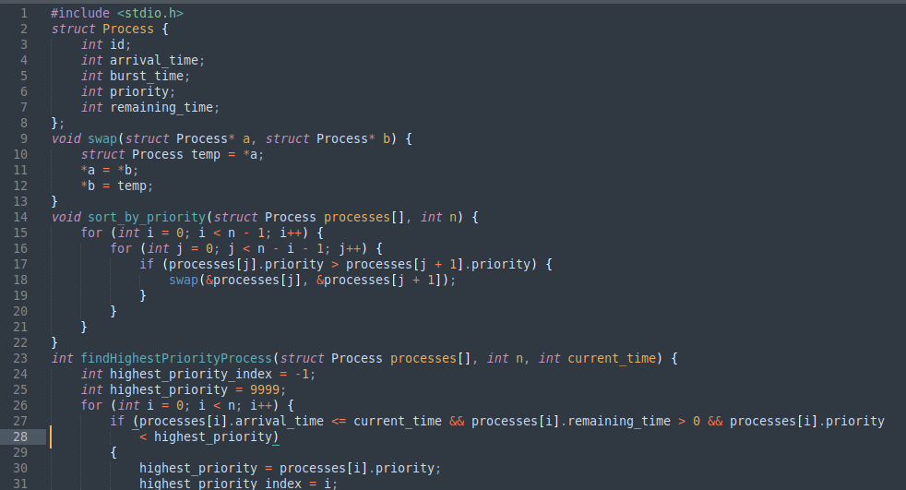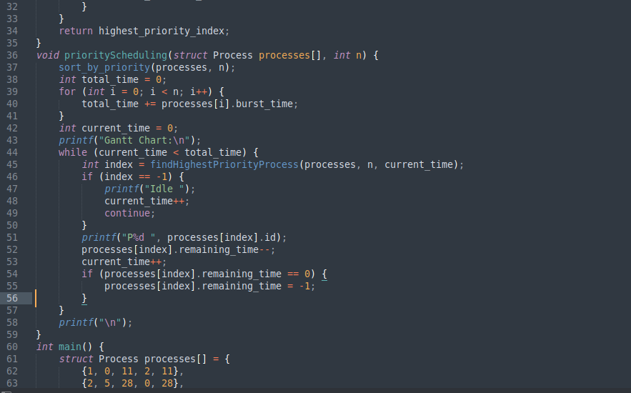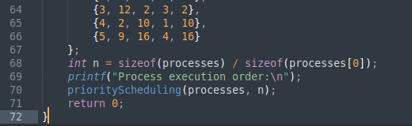
File: 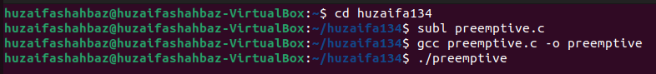
Output:

Task 2

Conclusion (write 3 to 5 lines conclusion of experiment you performed in Times New Roman 12)

